TUTORIAL 7
Boundary Value Analysis and Equivalence Partitioning

Bug ID: BUG-007
Webpage URL: playground.qajourney.net

TEST CASE EXECUTION
Test Case 1 – Minimum − 1
Test Case ID: BVA01
Input: 17
Expected Result: Age should be rejected.
Steps:
- Open the QAJourney Form Validation Playground.
- Enter all other required valid details.
- Enter 17 in the Age field.
- Submit the form.
- Observe the validation result.
Screenshot:

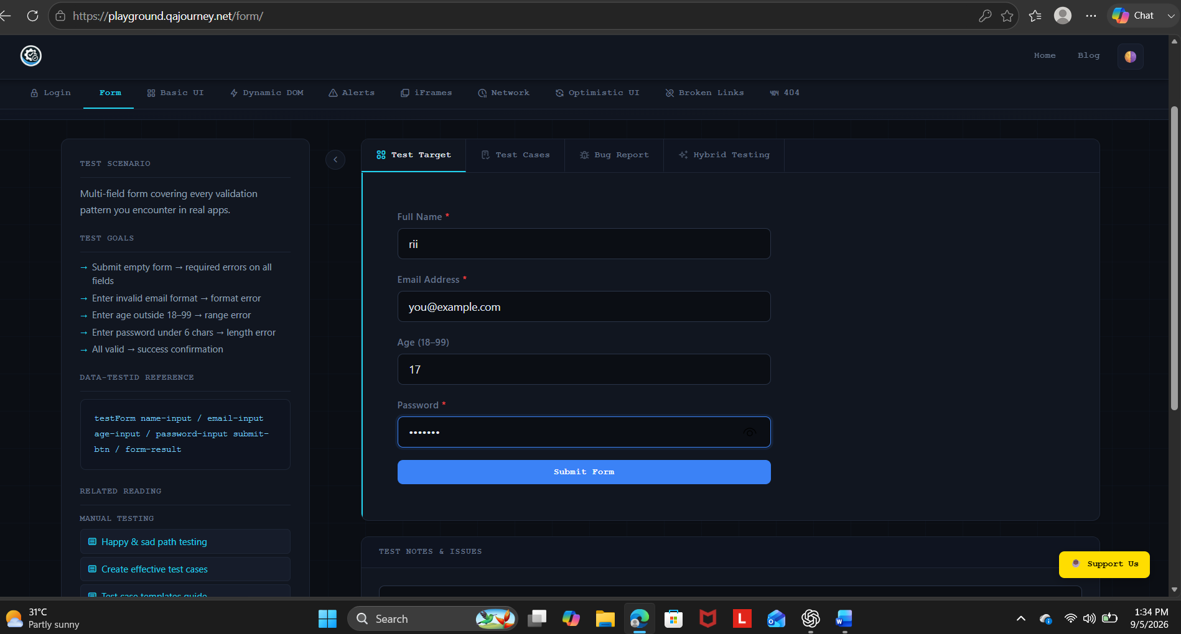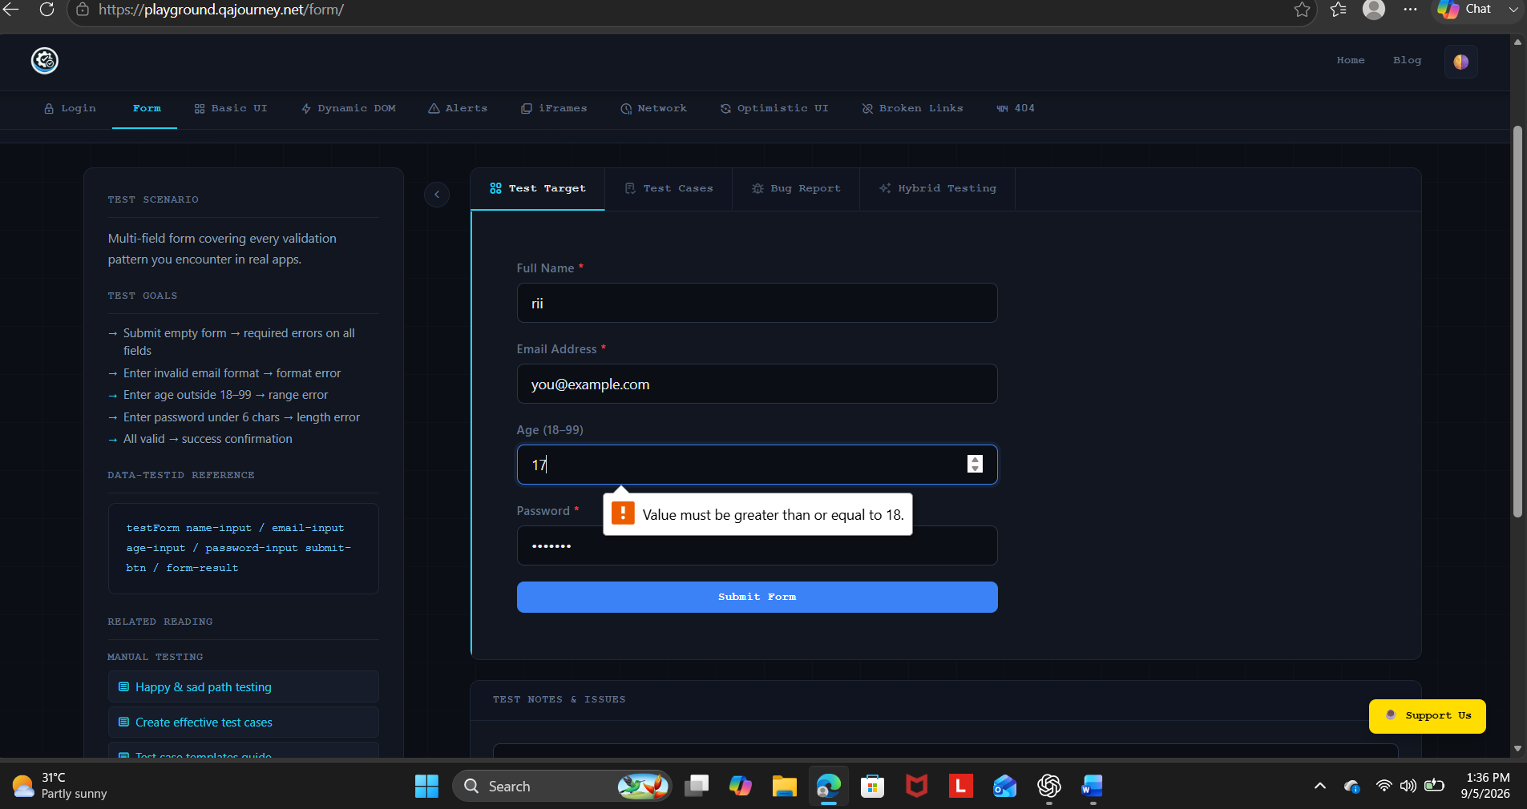Actual Result: Validation message displayed
Status: Pass

Test Case 2 – Minimum Value
Test Case ID: BVA02
Input: 18
Expected Result: Age should be accepted.
Steps:
- Enter valid details in all required fields.
- Enter 18 in the Age field.
- Submit the form.
- Observe the result.
Screenshot:
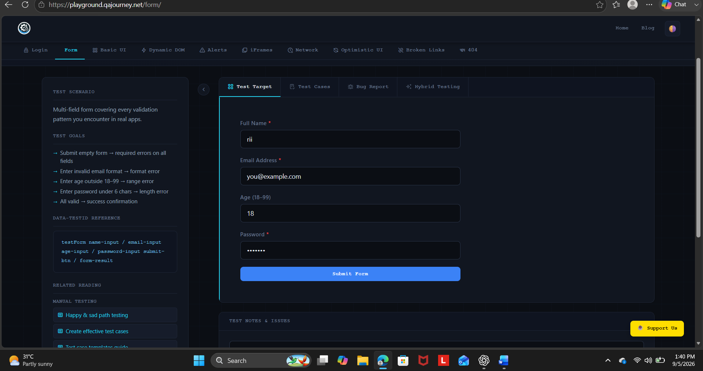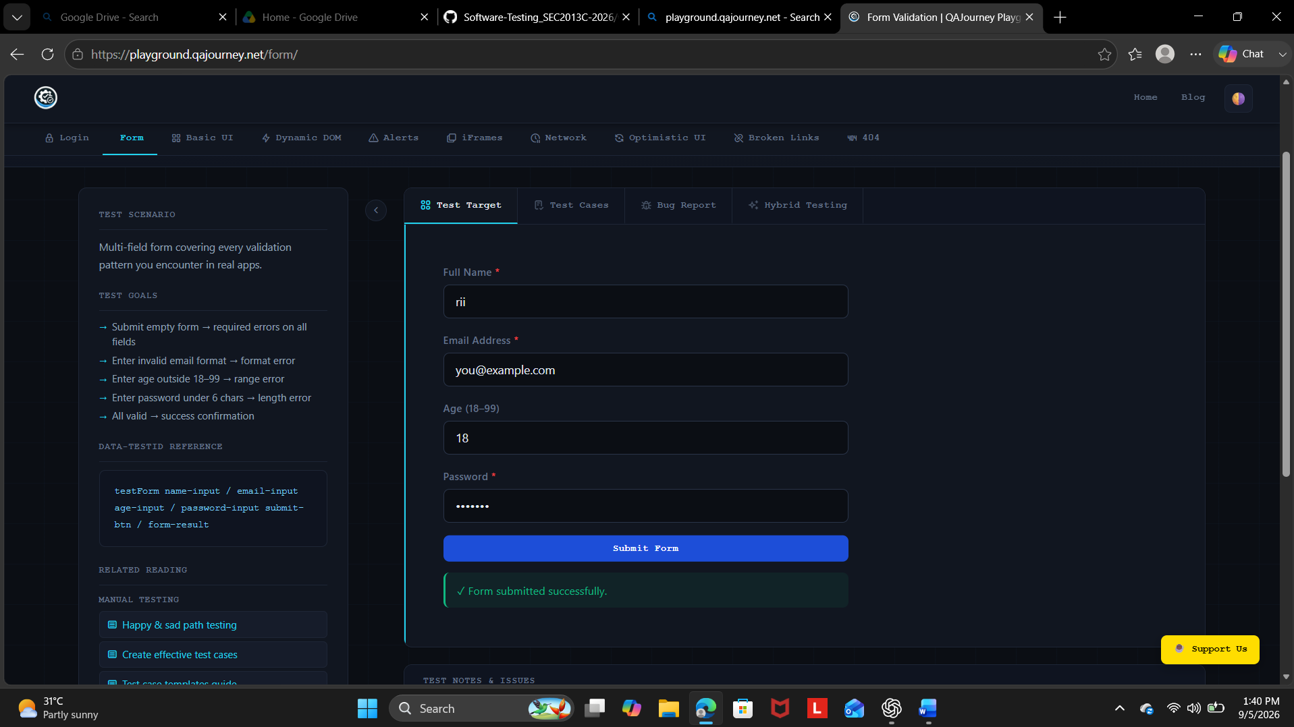
Actual Result: Form submitted
Status: Pass

Test Case 3 – Minimum + 1
Test Case ID: BVA03
Input: 19
Expected Result: Age should be accepted.
Steps:
- Enter valid details in all required fields.
- Enter 19 in the Age field.
- Submit the form.
- Observe the result.
Screenshot:
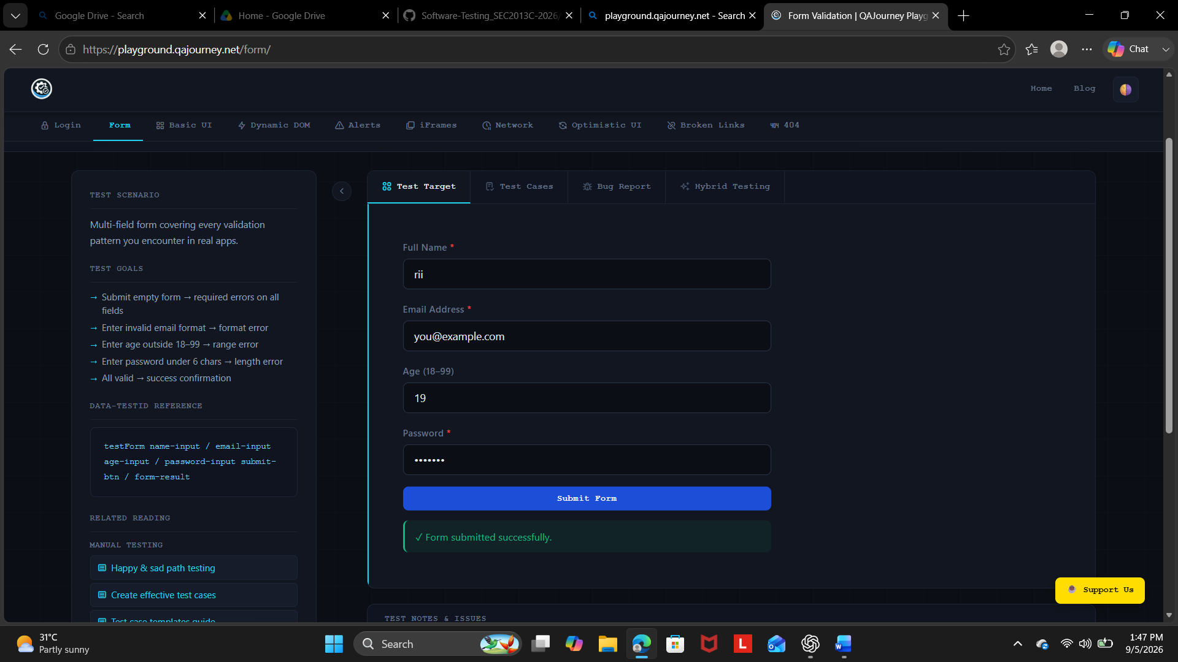
Actual Result: Form submitted
Status: Pass

Test Case 4 – Maximum − 1
Test Case ID: BVA04
Input: 98
Expected Result: Age should be accepted.
Steps:
- Enter valid details in all required fields.
- Enter 98 in the Age field.
- Submit the form.
- Observe the result.
Screenshot:
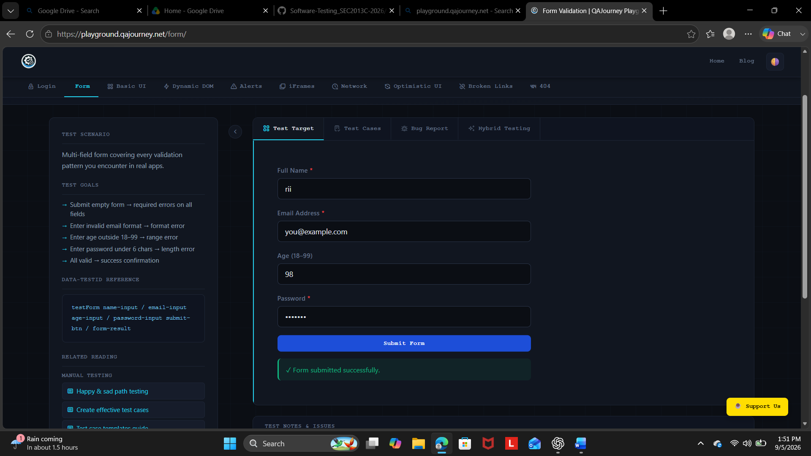
Actual Result: Form submitted
Status: Pass

Test Case 5 – Maximum Value
Test Case ID: BVA05
Input: 99
Expected Result: Age should be accepted.
Steps:
- Enter valid details in all required fields.
- Enter 99 in the Age field.
- Submit the form.
- Observe the result.
Screenshot:
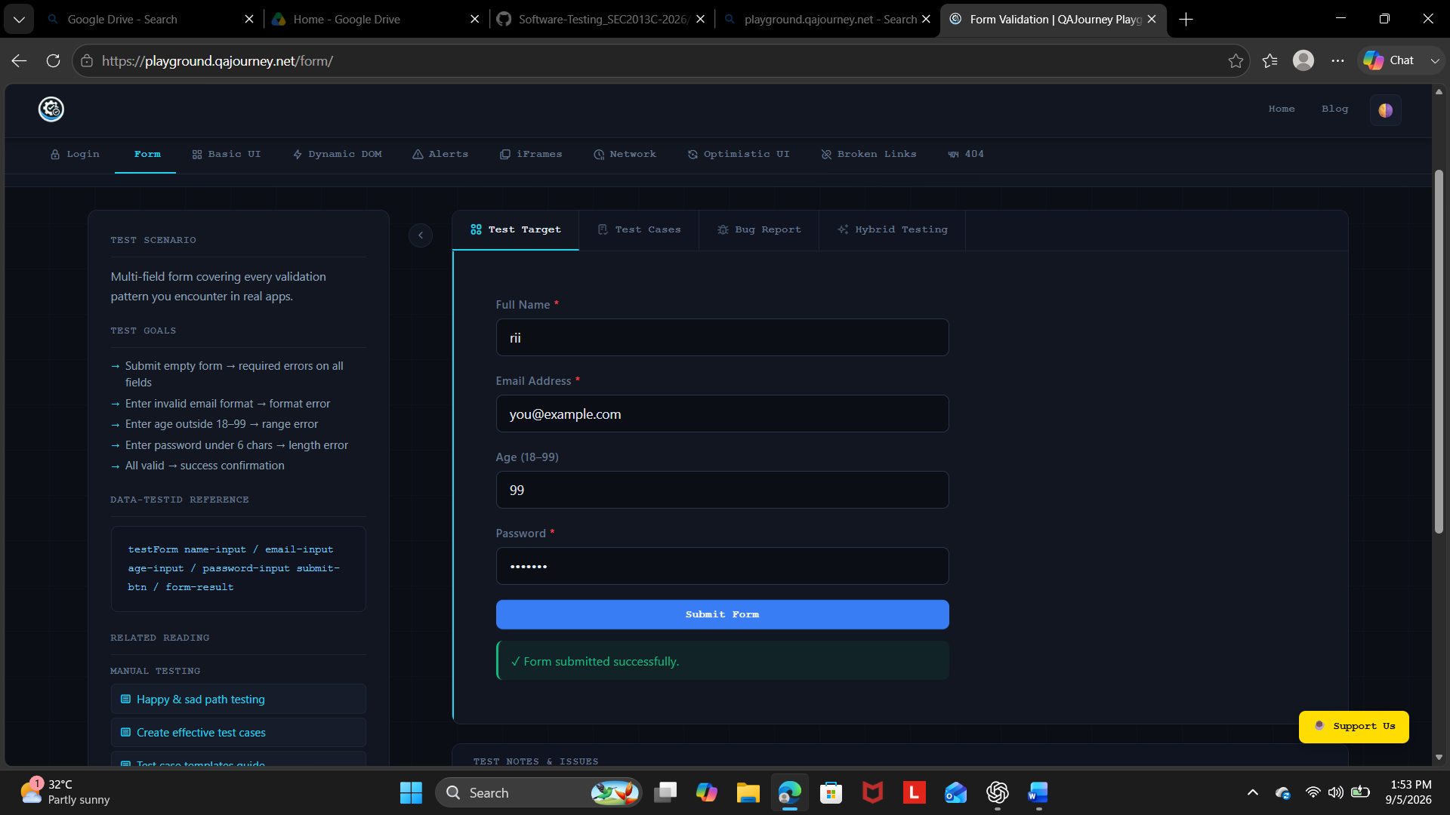
Actual Result: Form submitted
Status: Pass

Test Case 6 – Maximum + 1
Test Case ID: BVA06
Input: 100
Expected Result: Age should be rejected.
Steps:
- Enter valid details in all required fields.
- Enter 100 in the Age field.
- Submit the form.
- Observe the validation result.
Screenshot:
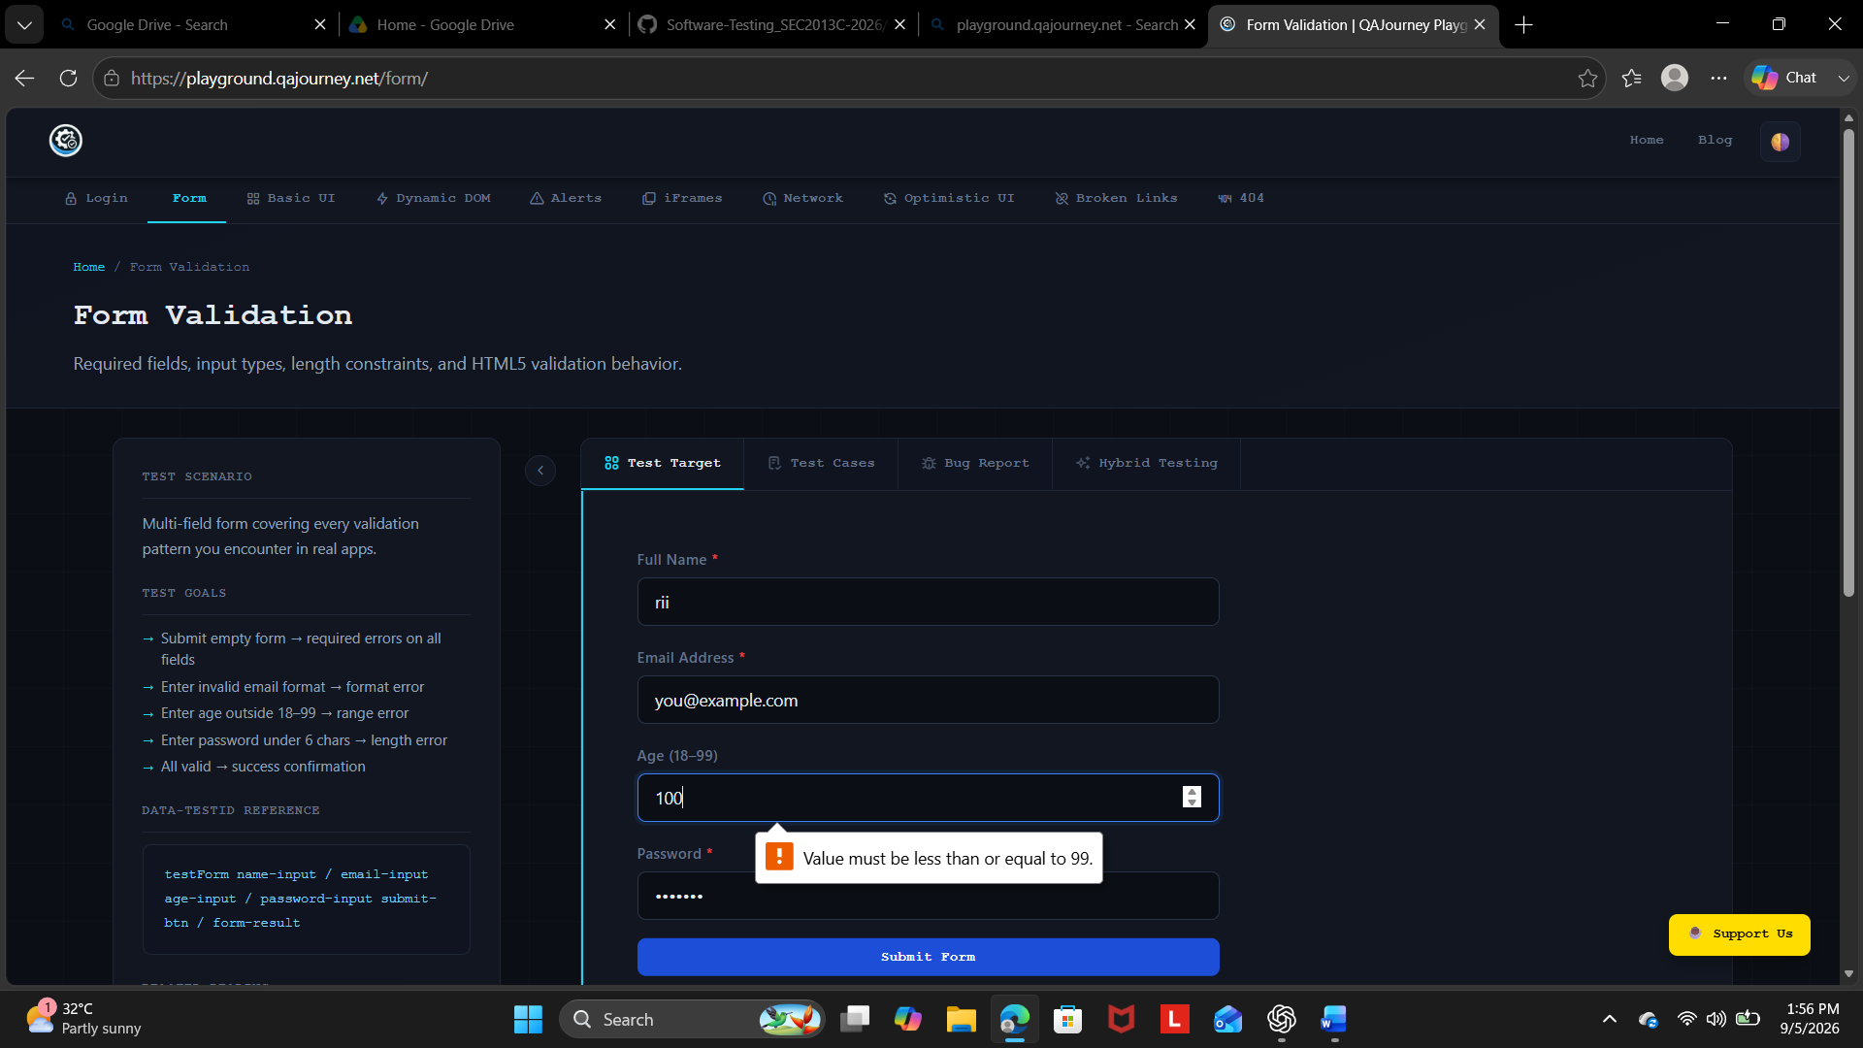
Actual Result: Validation message displayed
Status: Pass

EQUIVALENCE PARTITIONING TEST EXECUTION
Test Case EP01 – Invalid Partition
Input: 15
Expected Result: Age should be rejected.
Screenshot:
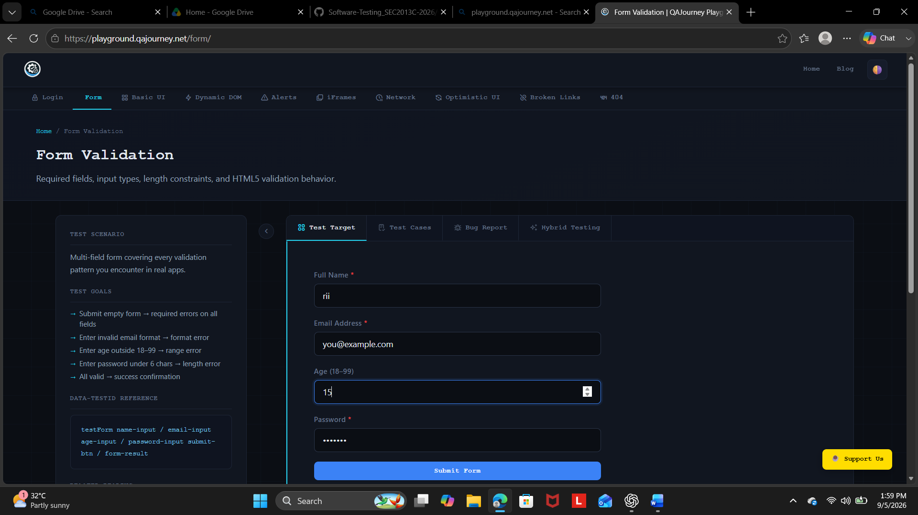
Actual Result: Validation message displayed
Status: Pass

Test Case EP02 – Valid Partition
Input: 30
Expected Result: Age should be accepted.
Screenshot:
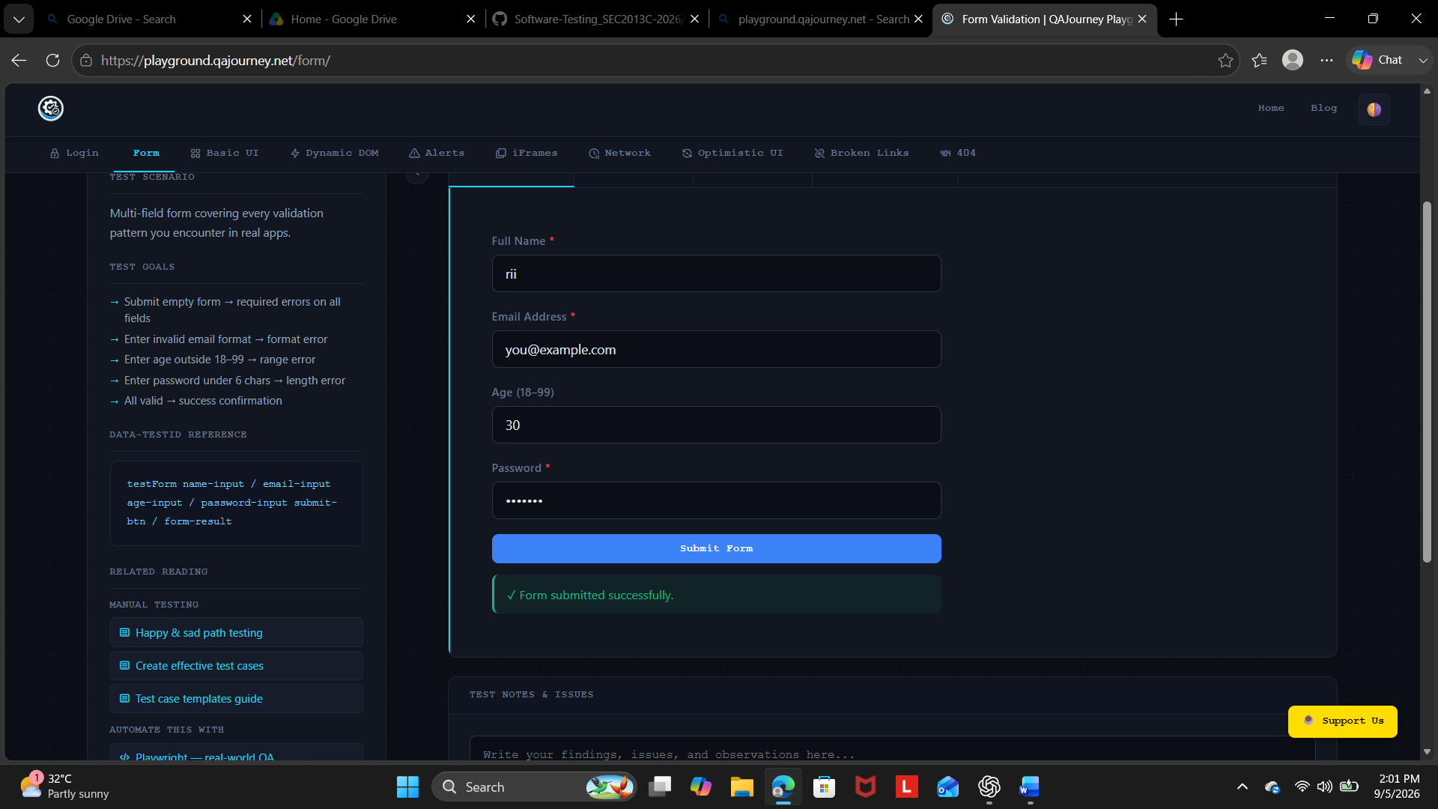
Actual Result: Form submitted successfully
Status: Pass

Test Case EP03 – Invalid Partition
Input: 100
Expected Result: Age should be rejected.
Screenshot:
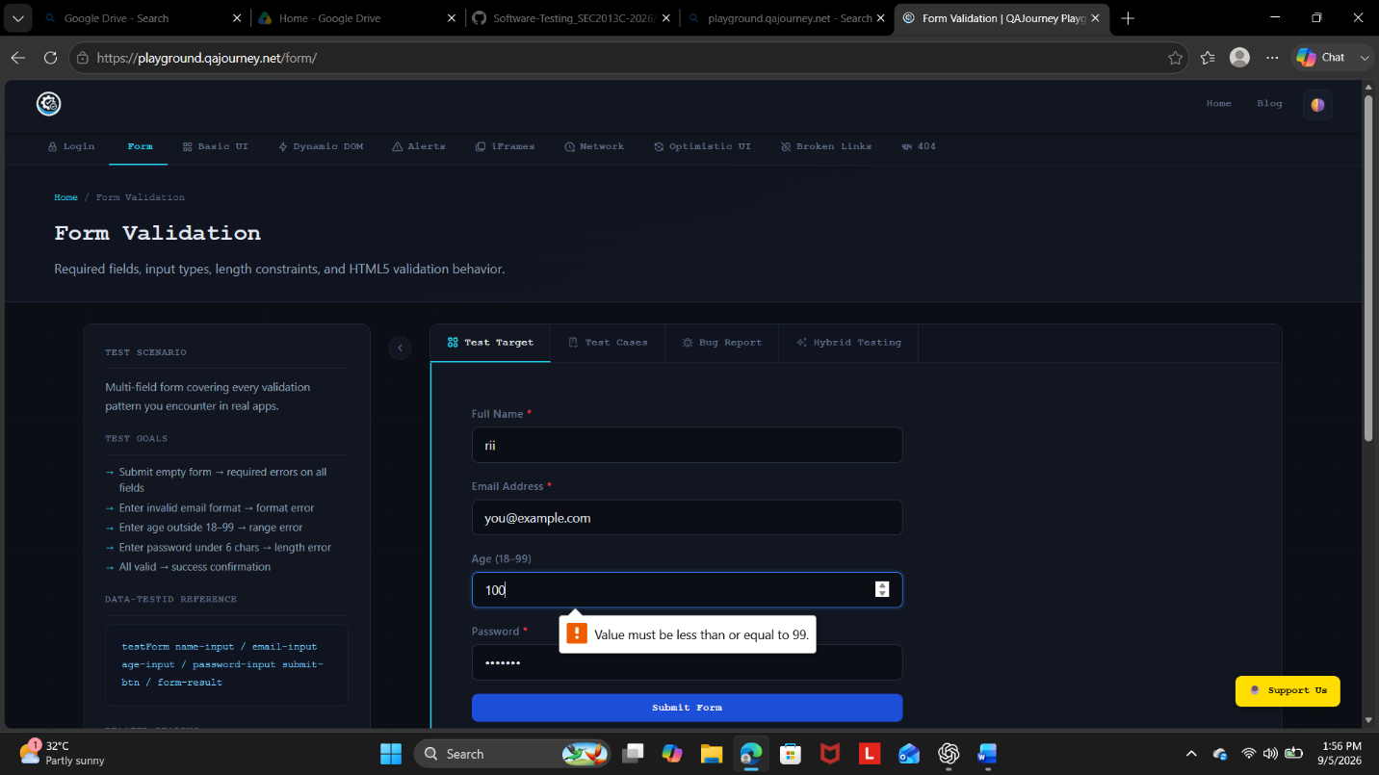

Actual Result: Message displayed
Status: Pass

